AD23532 – PRINCIPLES OF DATA SCIENCE
Ex8: Interactive Dashboards with Tableau
Aim

To create an interactive dashboard in Tableau using the Sample – Superstore dataset, with a bar chart (Sales by Category), a line chart (Sales trend over time) and a scatter plot (Profit vs Sales by Sub-Category), along with interactive filters and dashboard actions.

Algorithm

- Open Tableau and connect to the Sample – Superstore dataset (Excel/CSV file downloaded from Kaggle).
- Explore the data in the Data Source tab and check the dimensions (Category, Sub-Category, Region, Segment, Order Date) and measures (Sales, Profit).
- Create Worksheet 1, the bar chart:
  - Rename Sheet 1 to Bar_Sales_by_Category.
  - Drag Category to Columns and SUM(Sales) to Rows.
  - Sort the bars in descending order.
  - Drag Region to Color.
  - Enable Show Mark Labels under Label.
  - Optionally drag Region to Filters and select Show Filter.
- Create Worksheet 2, the line chart:
  - Create a new worksheet and rename it Line_Sales_Trend.
  - Drag Order Date to Columns and change it to Month (continuous).
  - Drag SUM(Sales) to Rows and Region to Color.
  - Format the axis as Currency if needed.
  - Optionally show a filter for Region or Category.
- Create Worksheet 3, the scatter plot:
  - Create a new worksheet and rename it Scatter_Profit_vs_Sales.
  - Drag SUM(Sales) to Columns and SUM(Profit) to Rows.
  - Drag Sub-Category to Detail and Category to Color.
  - Optionally drag Segment to Shape and add Average Line reference lines to both axes.
- Build the dashboard:
  - Click New Dashboard and rename it Sales Dashboard.
  - Drag the line chart to the top, the bar chart to the bottom-left and the scatter plot to the bottom-right.
  - Set the size to 1200 × 800 and use horizontal/vertical containers for alignment.
  - Add the title “Sales and Profit Dashboard”.
- Add interactivity:
  - Use Show Filter on the sheets for fields such as Region, Category and Year.
  - Go to Dashboard → Actions → Add Action → Filter. Set the source sheet to the bar chart and the target sheets to the line and scatter plots. Run the action on Select and clear the selection by showing all values.
  - Optionally add a Highlight action so that a selected Sub-Category is highlighted across the charts.
- Publish or export the dashboard:
  - Use File → Save to Tableau Public to publish.
  - Use File → Export → Image/PDF to export.

OUTPUT:

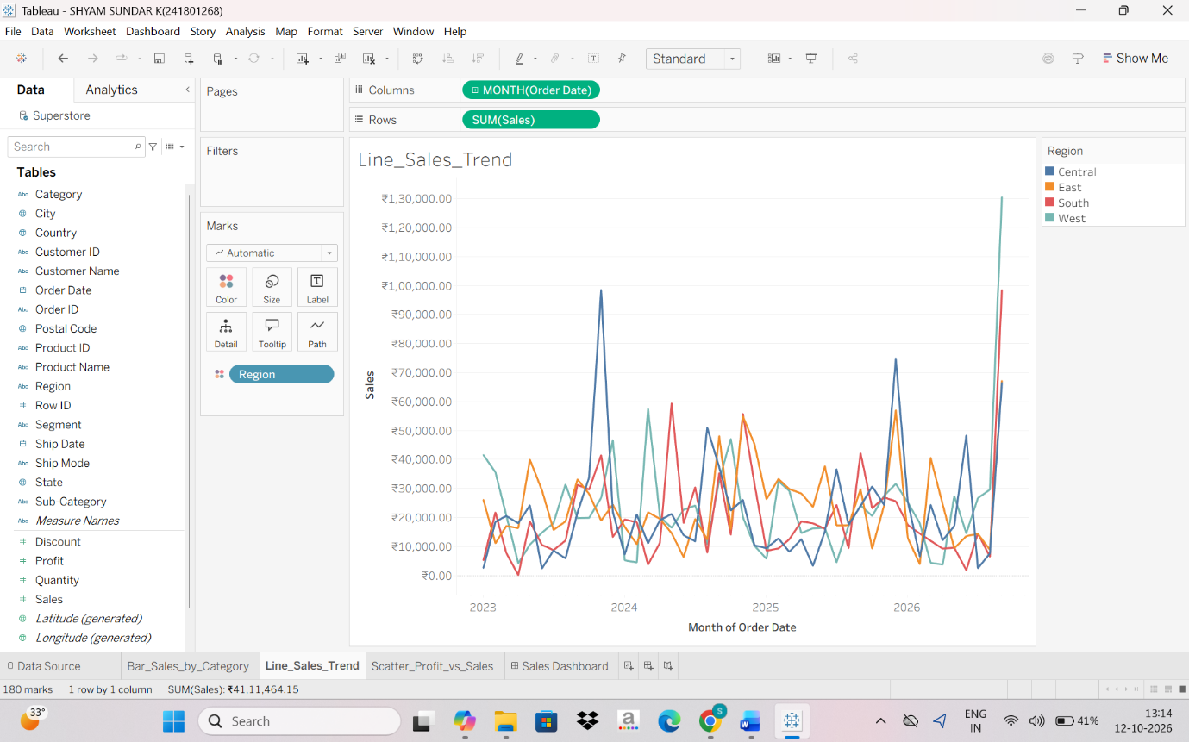
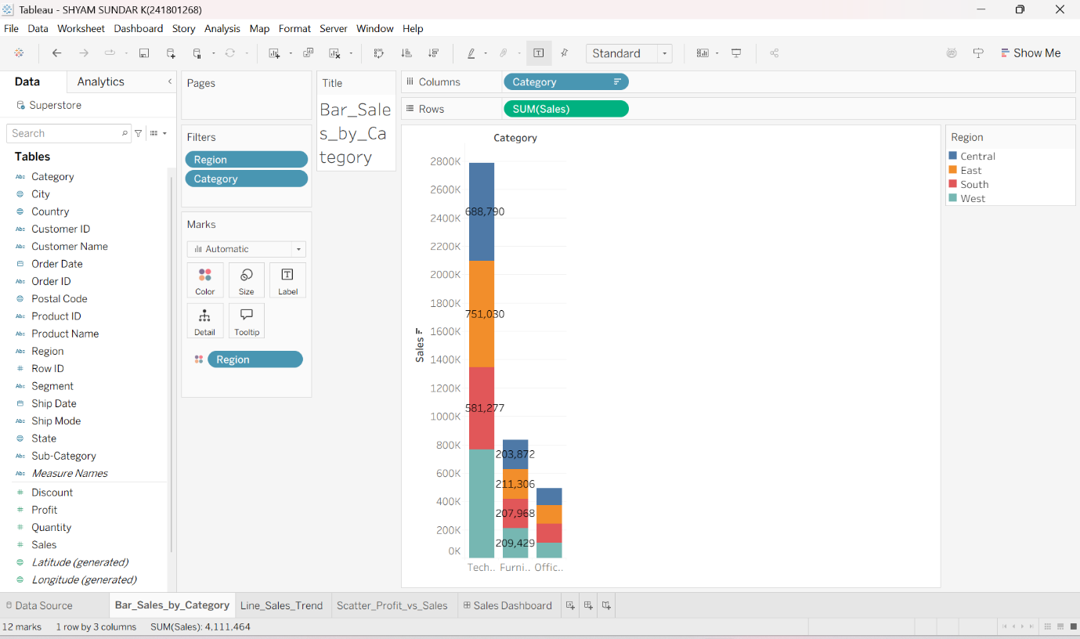
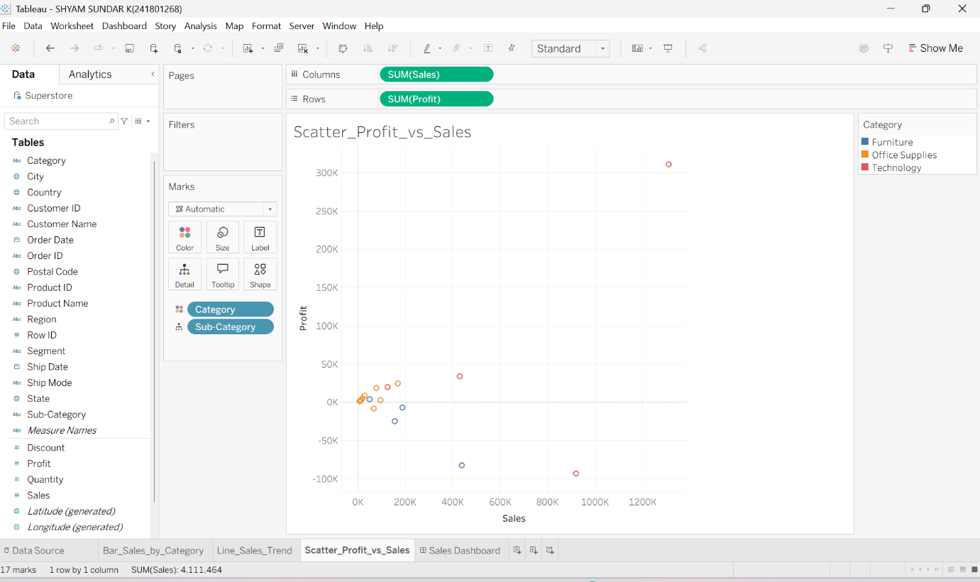
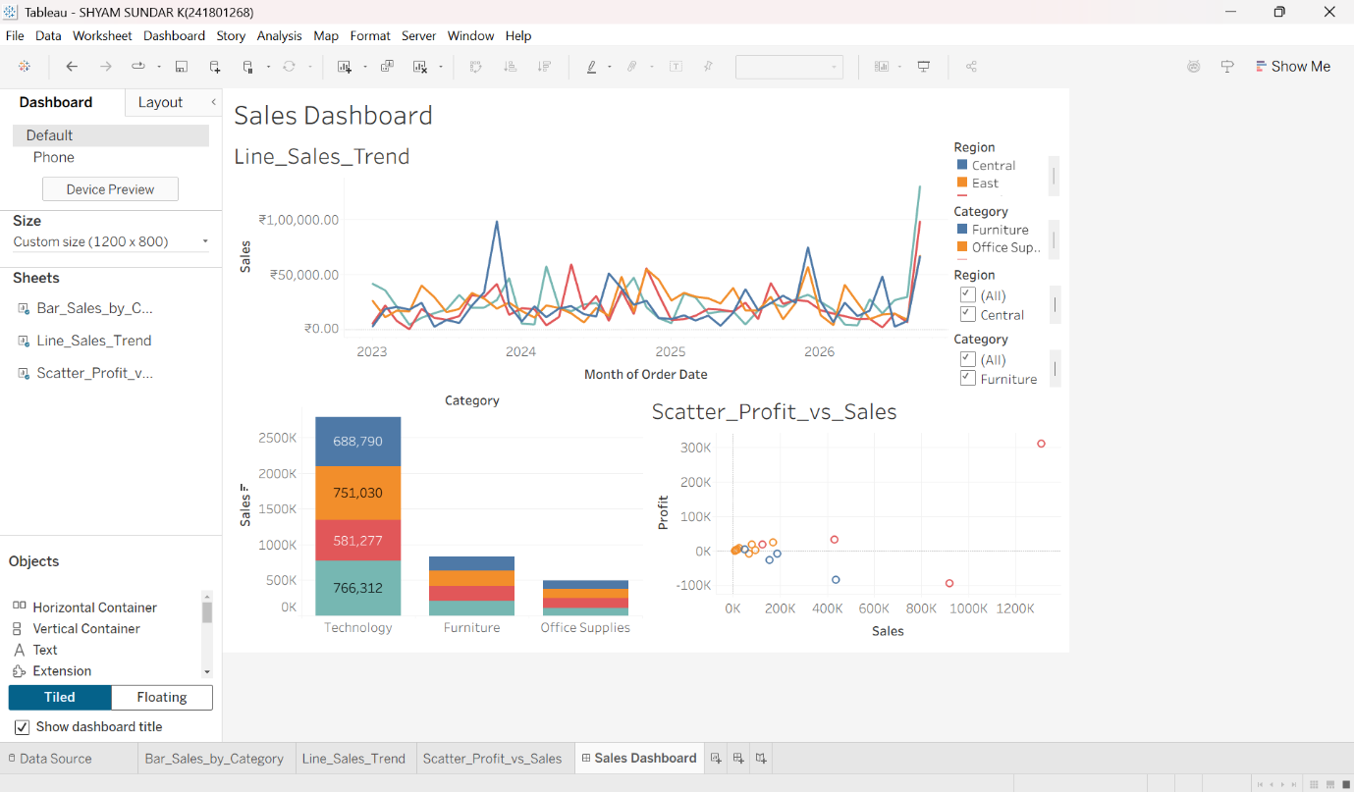

Result

An interactive Sales and Profit Dashboard was successfully created in Tableau using the Sample – Superstore dataset. The bar chart compares sales across product categories, with regions shown by color. The line chart shows how monthly sales trend over time for each region. The scatter plot shows the relationship between sales and profit for each sub-category. The Region, Category and Year filters and the filter/highlight actions let a selection in one chart update the others, which makes the dashboard useful for analysing sales and profit performance. Thus, interactive data visualisation and dashboard design using Tableau was implemented successfully.

